Set up AAD Organizational account for Quroum People

Assign minimum of a Power BI Pro License for the ADD org account

Why ?

Publish reports from Power BI Desktop

Demo creating datasets from dataflows using Power BI desktop

Demo creating reports from using Power BI desktop

Demo of 3rd party tools

-------------------------------------------------------------------------------------------------------------------------

Added as a Power BI Administrator

Tenant – how to add Power BI Admin - <https://docs.microsoft.com/en-us/power-bi/admin/service-admin-role>

Why

Allow access to the Power BI Admin portal – Tenant Settings

Access Workspaces - Power BI Admin portal – Workspaces

Run Restful APIs to monitor Power BI Service -

* What workspaces
* What users in the workspace
* What reports in workspace
* What datasets
* User Activity – how often viewed report, extracted data etc.

**Workspaces review**

Do they have any naming convention? - Yes / No

Are Dataflows, Datasets and Reports in different workspaces? Yes / No

Are groups assigned to workspace roles? Yes / No

Workspaces - Best Practice recommendations

Workspaces should be separated to contain different entities e.g. Dataflows, Datasets, Reports and Dashboards

Groups are assigned to the workspace roles

**Datasets review**

Are

If client requires reports to be published / created by Quorum personnel

Create AAD account for the client AAD organization e.g. [Robert.French@client.domain](mailto:Robert.French@client.domain)

Assign a PowerBI pro account to the above account

-------------------------------------------------------------------------------------------------------------------------------

Assign account as PowerBI capacity Administrator – this is done via the Azure Portal

Reason – when creating workspaces, they can be assigned to Premium capacity. This can only be if the account has been assgined as a Power

-------------------------------------------------------------------------------------------------------------------------------

Add user account to the Power BI administrator role

<https://docs.microsoft.com/en-us/power-bi/admin/service-admin-role>

Install the following App - aka.ms/capacityUsageReport

-------------------------------------------------------------------------------------------------------------------------------

Create following AAD groups

OrgName_PowerBI_Admin_Security – Azure Active Directory **Security** Group

In this group will be the accounts which have overall administrative control of the PowerBI

-------------------------------------------------------------------------------------------------------------------------------

Installation of Power BI desktop

Record all the values of each of the Power BI tenant admin settings

Review all the values compared against recommended settings – company dependant

Power BI Service Tenant ID

Open the following URL app.powerbi.com using an internet browser and sign in using an FSI account.

Once signed into the Power BI Service for FSI, go to the top right-hand side, click once with left hand mouse button on the "?" (see step 1)

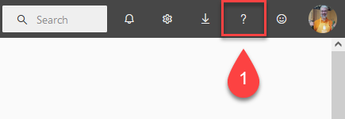

From the menu that appears, click once with the left-hand mouse button on the menu item 'About Power BI'

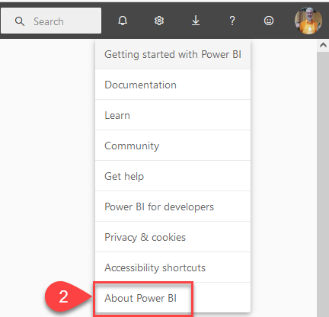

This will open the window seen below; click once with the left-hand mouse button on the value 'Tenant URL'. Last step is to click on the copy button.

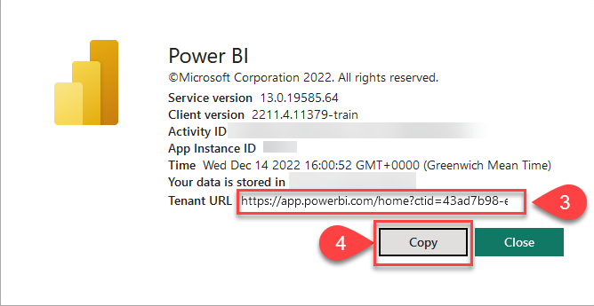

Please email the value sent the value from the Tenant Url, which should look something like this

<https://app.powerbi.com/home?ctid=43ad7b98-e7ac-4315-9137-5e0a60zxh7f1>